**Collegetown Neighborhood Guide**

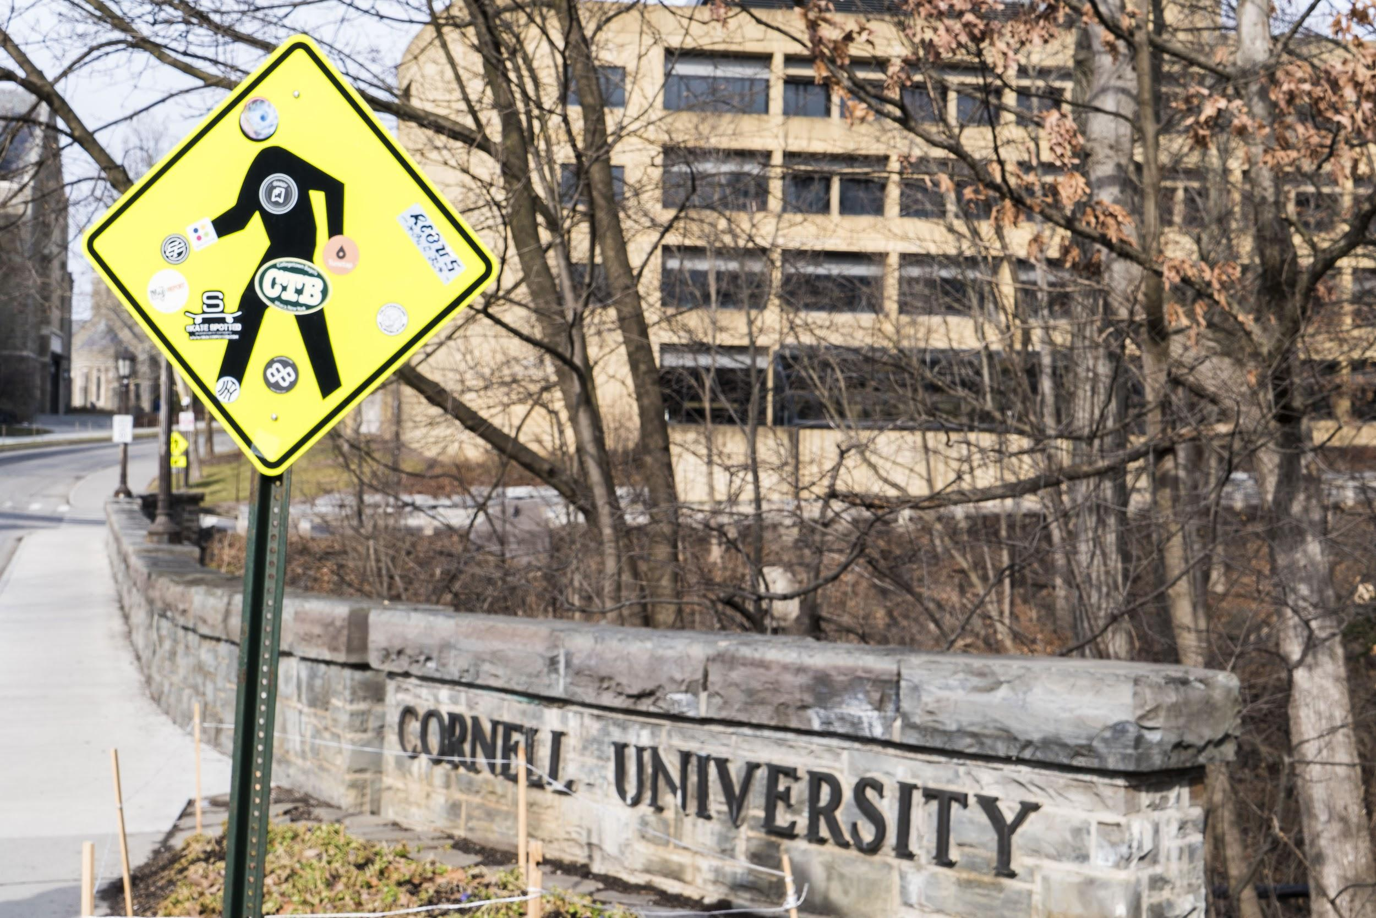

Welcome to Collegetown! Often considered Ithaca’s second town, this attractive neighborhood has everything a college student could ever dream of. Collegetown houses most of Ithaca’s student population in a collection of modern, multi-story apartment units and tradition post-Victorian homes, while also offering some of the best amenities and activities in the city.

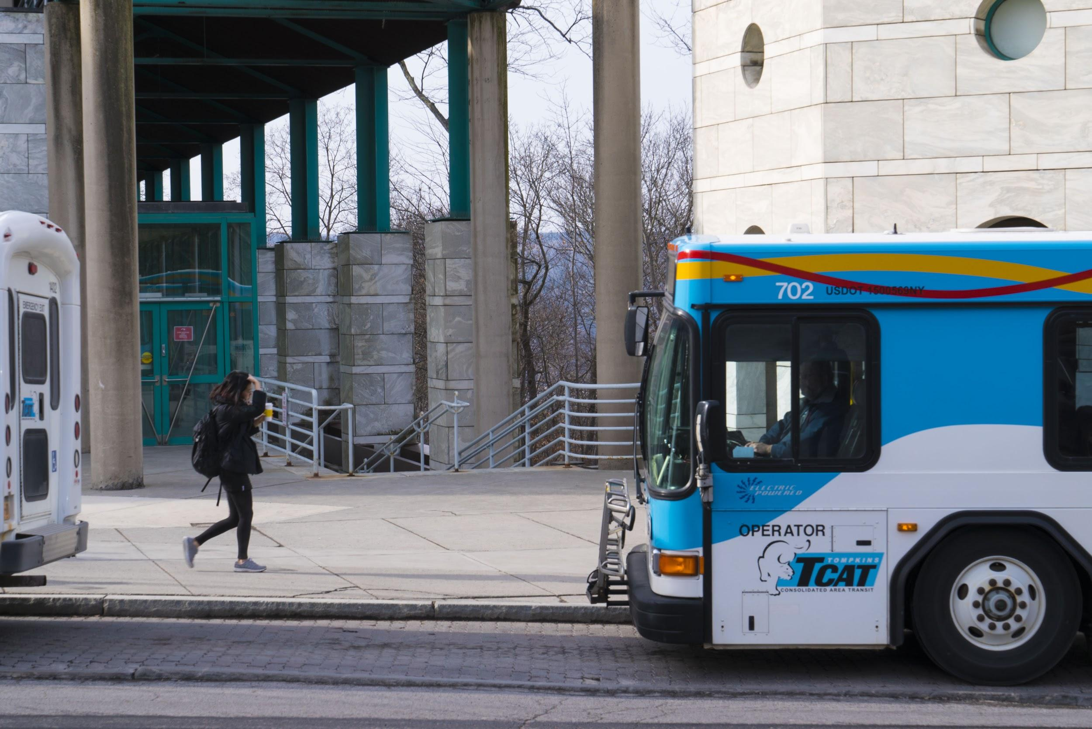

Perched at the top of East Hill, Collegetown is located between the Cornell University campus and Ithaca’s downtown. Its strategic location allows Collegetown residents to easily explore everything Ithaca has to offer. If the weather is nice and in the mood for an easy downhill walk, Downtown Ithaca is less than a mile from Collegetown. If you’re a nature person, or just enjoy immersing yourself in beautiful natural scenery, try taking the Cascadilla Gorge Trail for your trip downtown. Your Instagram followers will be in awe of your beautiful surroundings. For your return trip, or for the 300 days of the year when it’s raining, snowing, or too cold, the TCAT runs 11 different routes that include stops in Collegetown.

FUN FACT: If you’re not sure which bus to use, you can now plan your TCAT trip with [Google Transit](https://www.google.com/maps/dir///@42.4422141,-76.5002451,15z/data=!4m2!4m1!3e3?hl=en&authuser=0)! Just enter your starting point and destination, and let Google Maps figure out the rest.

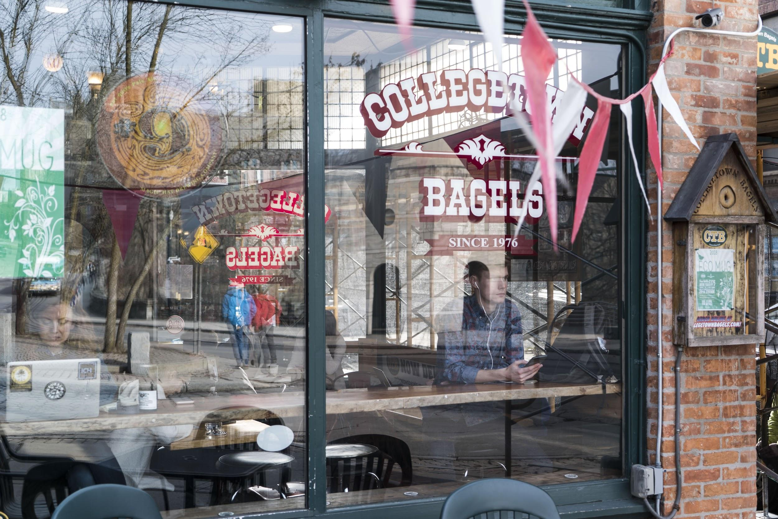

Collegetown’s relaxed urban setting is refreshing to the many students who are in the area regularly. “The best part is the convenience,” said Cindy Jun, a current Cornell University student. Collegetown is home to countless amenities including iconic restaurants, a 24/7 printing center, locally-owned organic grocery stores and a USPS that is open even on Sundays. Even with all the conveniences that are targeted towards students, Collegetown “feels completely different from being on campus. It’s a nice, different air from the stressed academic environment, even though you’re not really that far.”

Some of the most loved Collegetown amenities are its several coffee shops. Whether you prefer iced coffees from Dunkin’ Donuts, holiday themed espresso drinks from Starbucks, or quad shot java jolts from Collegetown Bagels, you’ll find the perfect drink to match your caffeine needs. Collegetown’s coffee shops are also a favorite spot for getting work done. Walk into any coffee-selling establishment at any given time, and you’ll find several students sipping on their drink of choice with books laid out on the table. Jun’s friend, Rebecca Lucas, offers an additional endorsement for studying at coffee shops as she memorizes Italian verbs: “We come here every day. We like the atmosphere here better than we like the library’s. We get a lot done and we relax at the same time.”

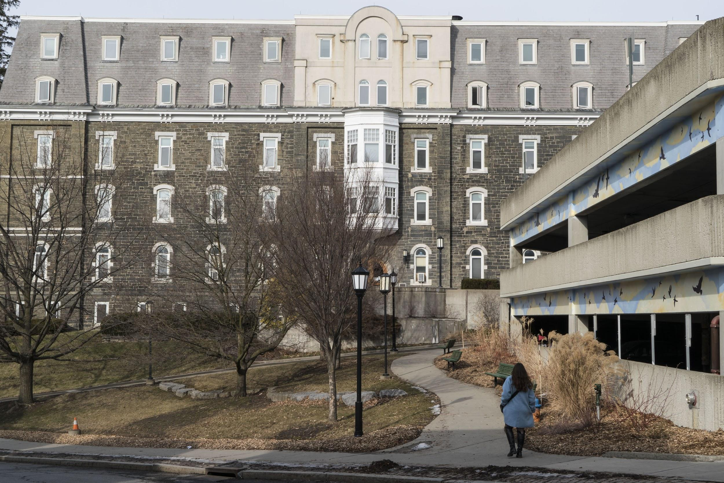

Even if Collegetown feels worlds away from Cornell, its proximity to the campus has definitely influenced the different styles of architecture that are found on every block. The different architectural styles seamlessly intermix with Cornell’s academic buildings, creating the picturesque environment that residents get to experience every morning. There is a type of building for each unique and diverse resident in Collegetown. Whether you love apartment-style living in modern high rises and townhouses, or prefer a more cozy setting in charming post-Victorian houses with gardens, you can find them all within Collegetown’s confines.

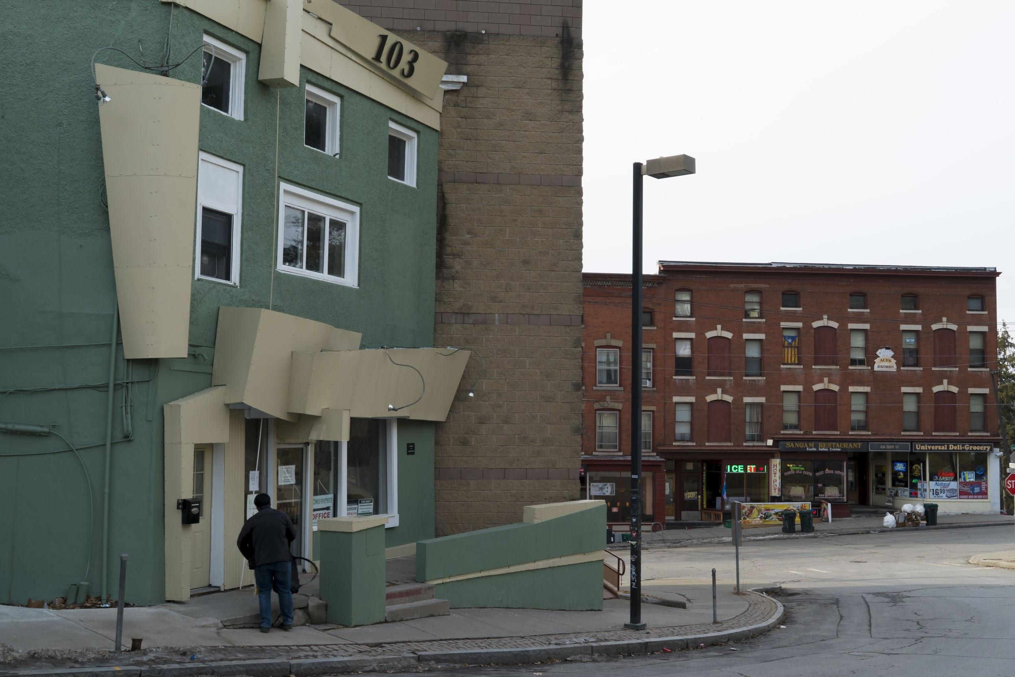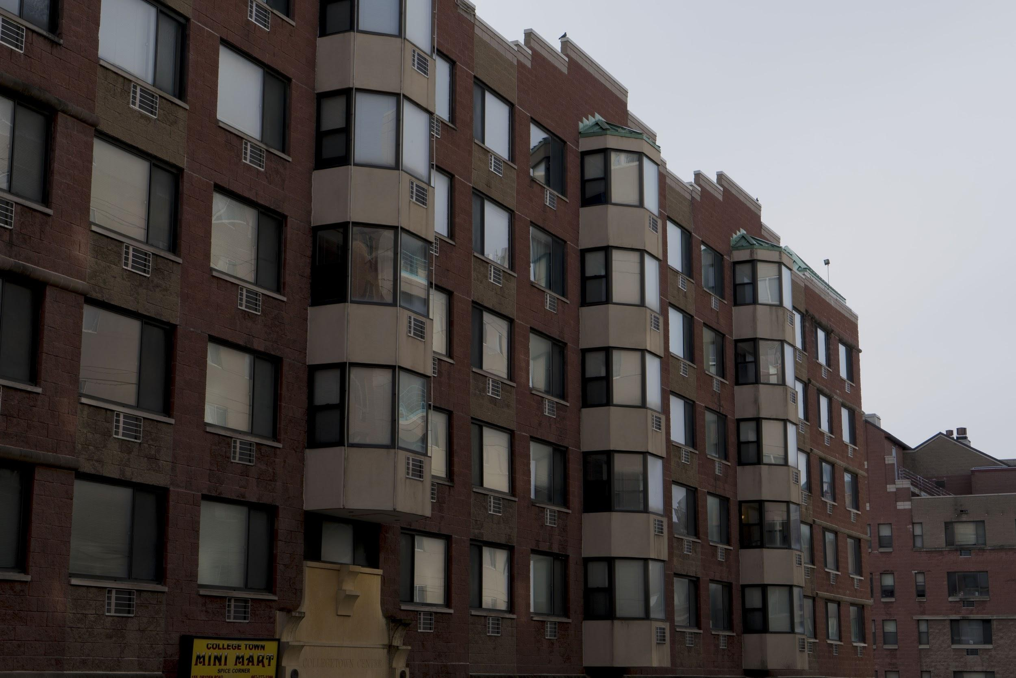

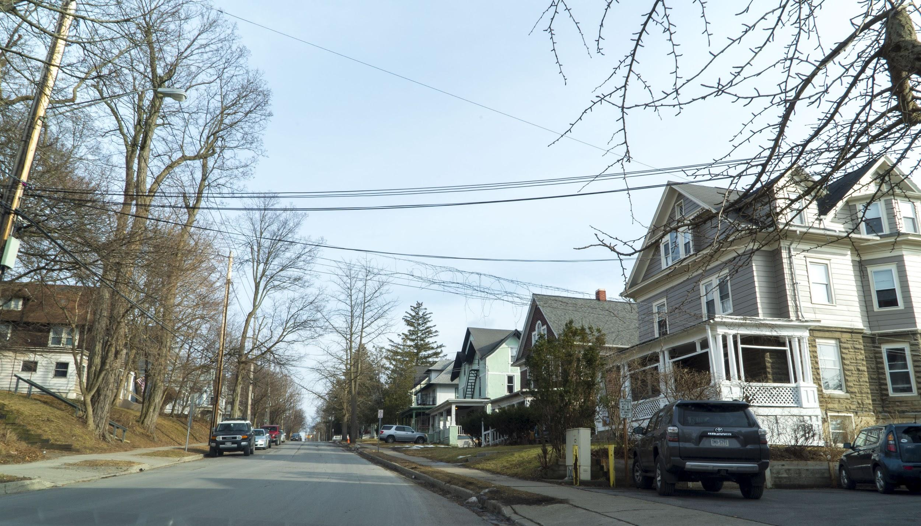

As with most neighborhoods in Ithaca, one of the best assets of Collegetown is the food. “I come mostly for the food. You can find everything you need here and it’s usually the best of the best,” explained Kenneth Yeung, a hospitality and management student. A quick walk through the neighborhood will bring you to some of the best ramen and pho in town, and only for just a few dollars. Also, several food spots like Collegetown Bagels, Luna’s, and Insomnia Cookies, remain open past midnight if you’re hankering for a bite to eat late at night. In the immortal words of Yeung, “If you can’t find food in Collegetown at 2am, you’re not trying hard enough.” Well said, good man. Well said.

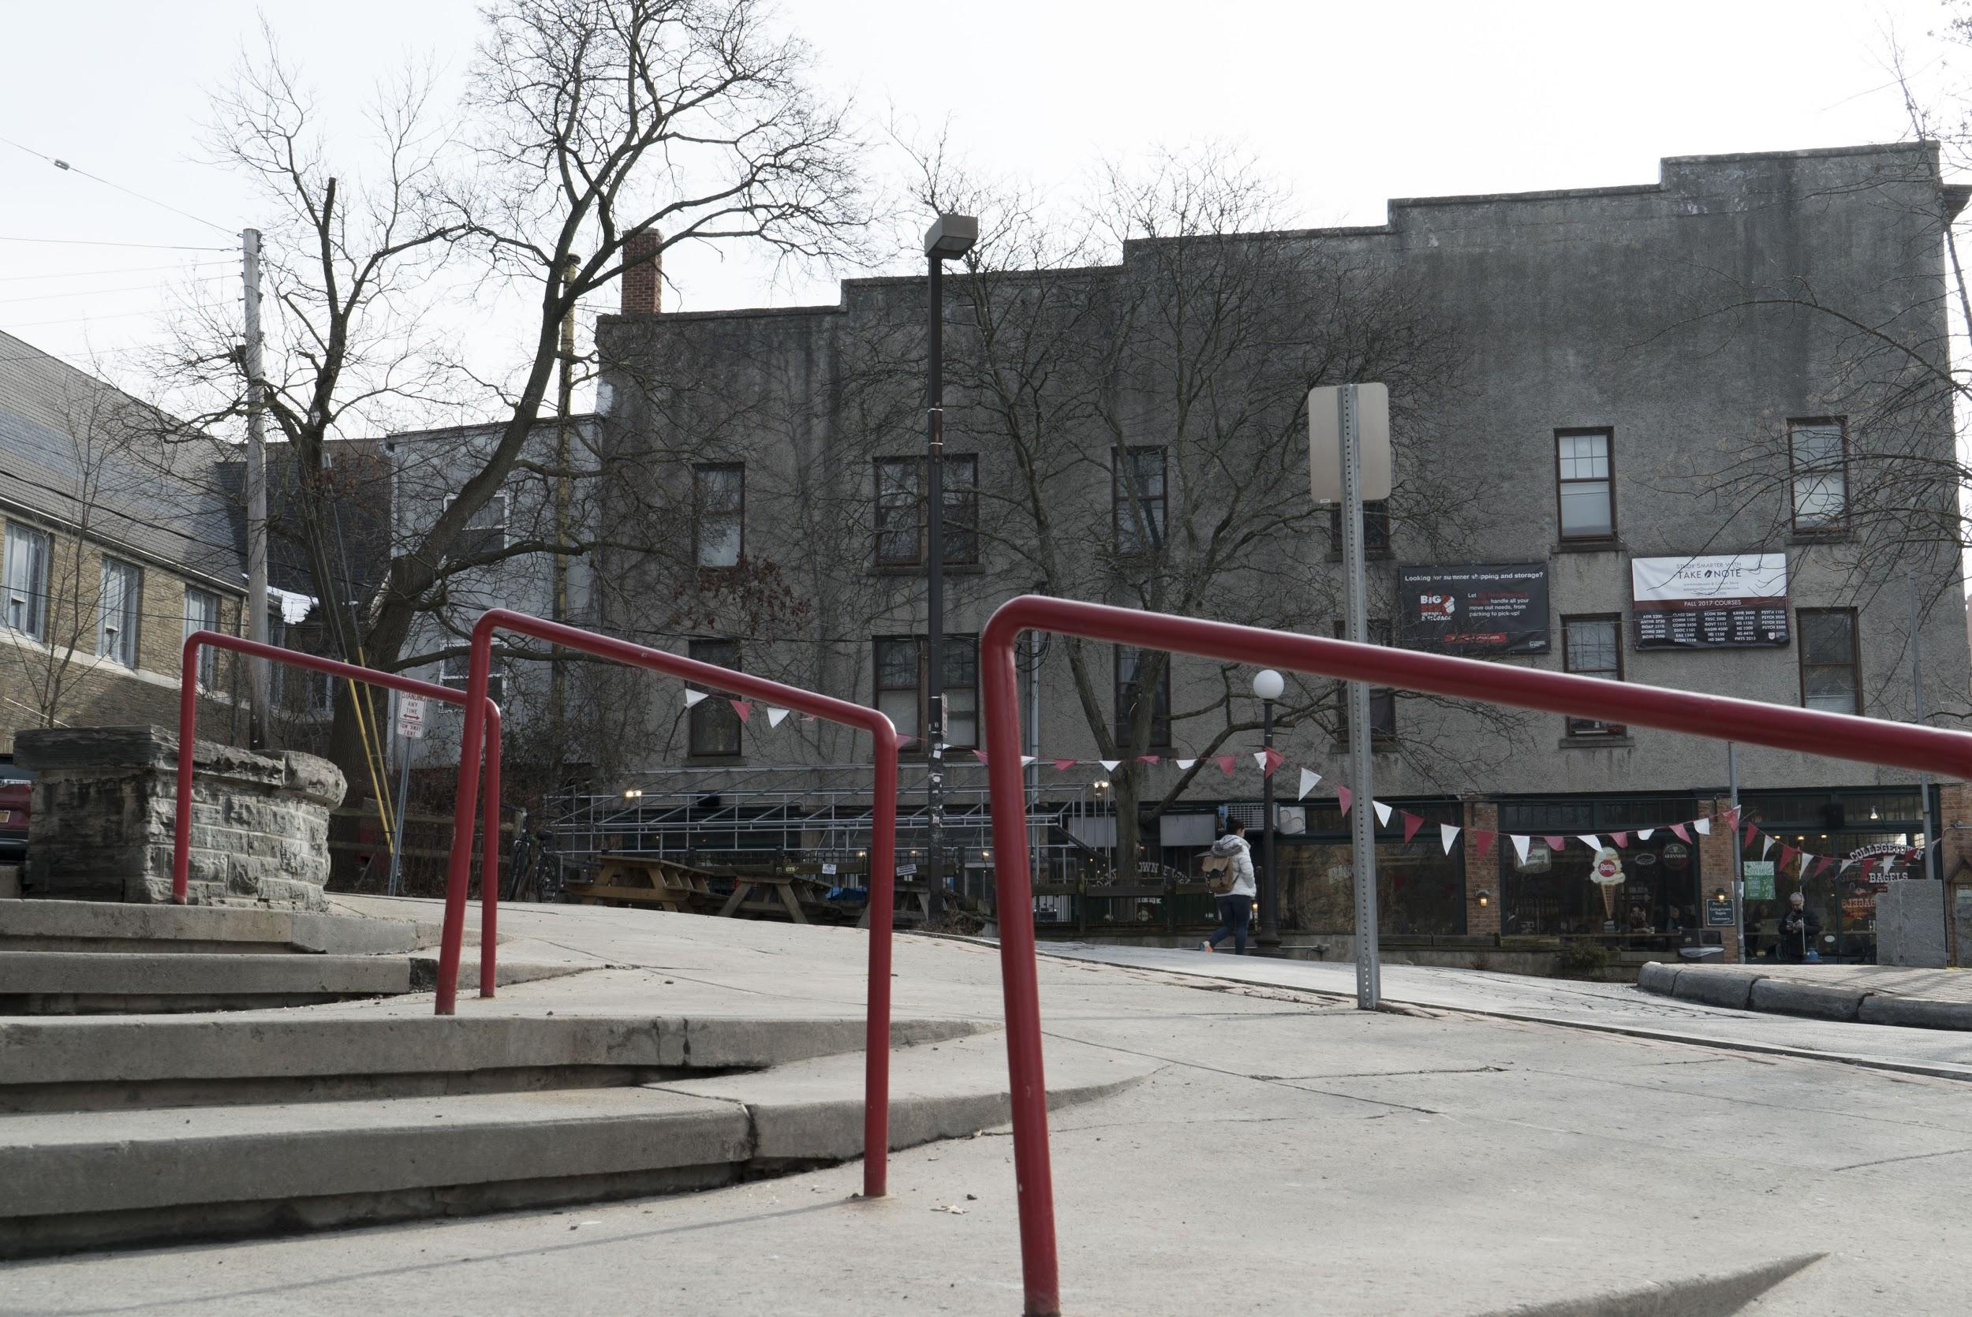

We hope you’ve enjoyed this introduction to Ithaca’s Collegetown neighborhood. If you’re interested in taking advantage of its many useful and tasty amenities, be sure to check our area listings [here](https://cspmgmt.managebuilding.com/Resident/PublicPages/ApartmentSearch.aspx).